Transit gateway-

A transit gateway is a network transit hub that you can use to interconnect your virtual private clouds (VPCs) and on-premises networks. Or AWS Transit Gateway connects your Amazon Virtual Private Clouds (VPCs) and on-premises networks through a central hub. This connection simplifies your network and puts an end to complex peering relationships. Transit Gateway acts as a highly scalable cloud router—each new connection is made only once.

Transit gateway terminology

Attachment – Each connected VPC,VPN or direct gateway must be attached to transit gateway

Association – Each attachment is associated to exactly to one route table Route table can be shared between attachment

Propagation – propagation routes to one or more route table support static and dynamic routes

Simple Diagram how route table Worked

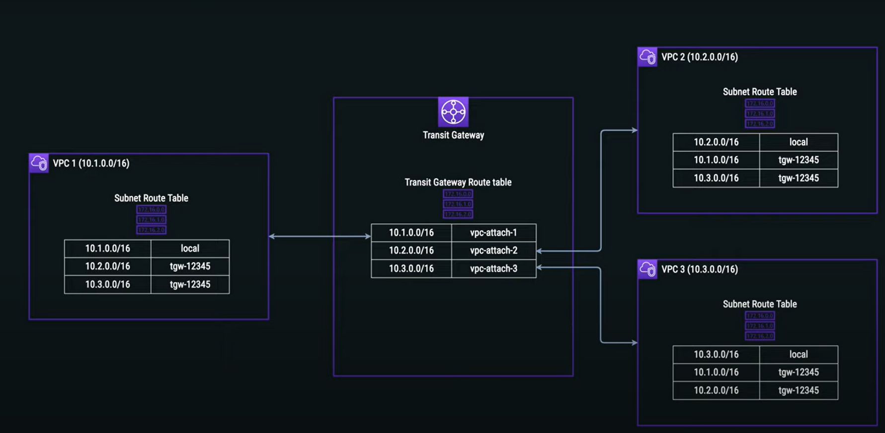

# ****The basics about transit gateway****

**AWS Transit Gateway (TGW)** is a cross account, per-region service available to VPCs and VPNs in those regions.

**AWS Transit Gateway (TGW) Route Tables** – the dynamic and static routes that decide the next hop for VPCs/VPNs based on the destination IP address. AWS Transit Gateway (TGW) comes with one default table. You can add many route tables.

**AWS Transit Gateway (TGW) Attachment** – AWS Transit Gateways (TGW) can have VPCs or VPNs as attachments. A VPC or VPN can be attached to only one AWS Transit Gateway (TGW) route table. A VPC or VPN can be attached to one or more AWS Transit Gateways (TGW).

**AWS Transit Gateway (TGW) Route domain** – Similar to virtual routing and forwarding (VRFs) in traditional networks, a route domain is conceptual group of VPCs and/or VPNs attached to a single route table.

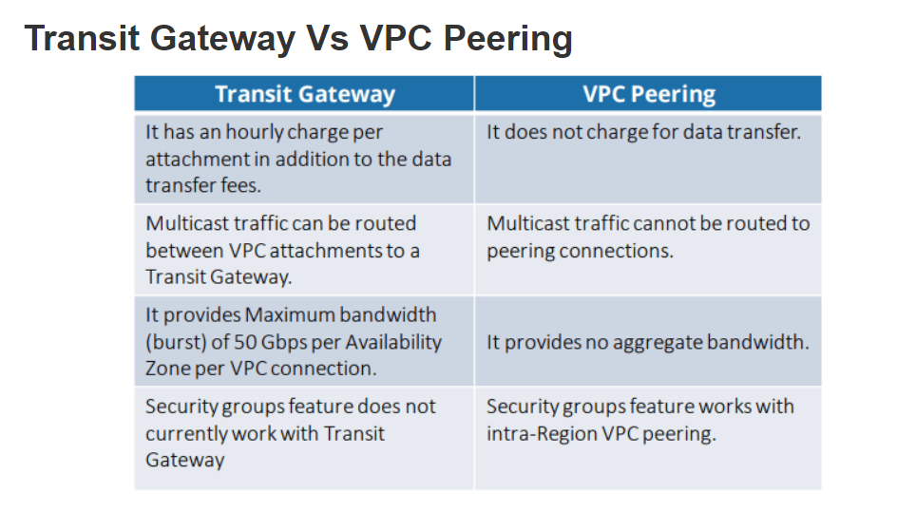

How to create a transit Gateway?

1. You can give the name and description
2. Keep ASN default
3. And mark rest of options

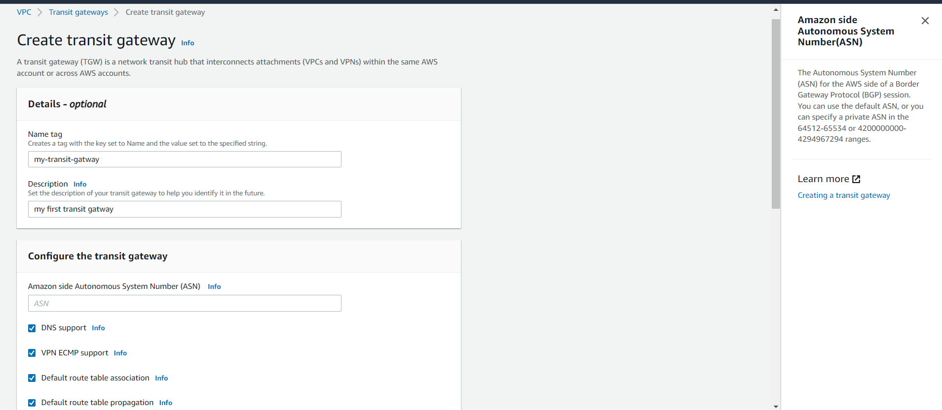

1. Select transit gateway auto sharing options **cross-account**
2. Chose the CIDER block for the gateway
3. And opt for the name and tag for the gateway

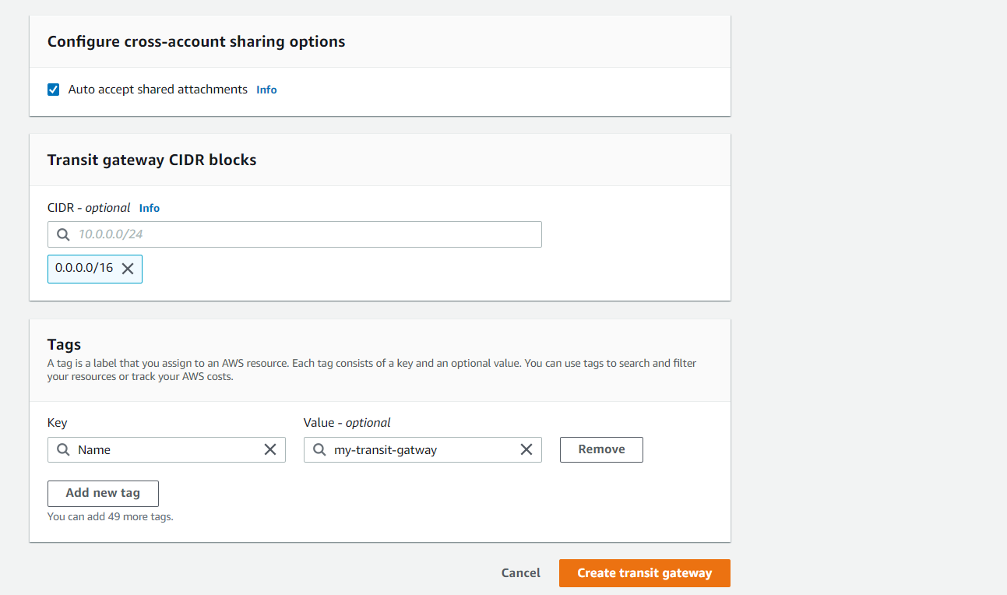

Create transit gateway attachment

1. Give a gateway name and tag
2. Mention the gateway ID
3. Select the attachment type according to requirement

* VPN
* VPC
* Peering connection
* Connect

1. Select the DNS default option

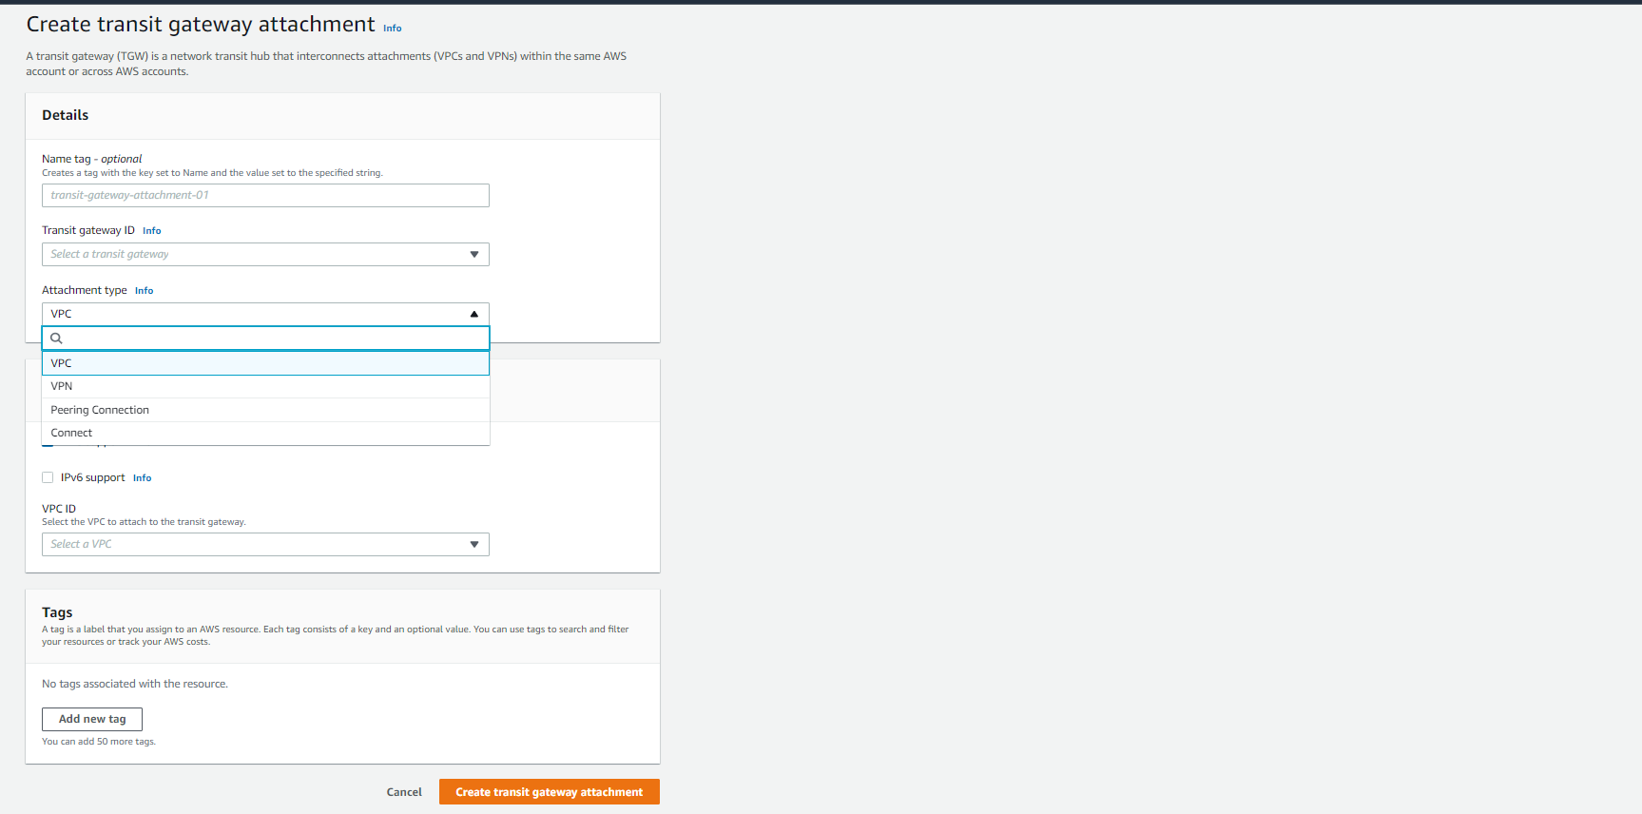

Now you can attach VPC to your transit gateway for both the account

## **Limitations**

* Transit Gateway peering only possible across regions, not within region.
* You can connect to a maximum of three Transit Gateways over a single Direct Connect Connection for hybrid connectivity.
* Transit Gateway doesn’t support routing between VPCs with overlapping CIDRs.